
Dashboard Design

Date | 24 September 2026
Team ID | desaisabiha1212@gmail.com
Project Name | Online Food Delivery Analysis Using Tableau
Maximum Marks | 5 Marks

Activity 1: Interactive and visually appealing dashboards
Creating an effective Streamlit dashboard involves presenting business data stored in Snowflake through clear, interactive, and easy-to-understand visualizations. Students should design the dashboard so that users can quickly understand important KPIs, trends, comparisons, and business insights.
- Colour and Theming: Suitable colours are used to make dashboards attractive and readable.
- Interactive Filters and Slicers: Filters are used where required to explore the data.
- Drill-Down Capabilities: Users can explore different categories and survey responses.
- Responsive Design: Dashboards are arranged for better viewing and understanding.
- Custom Visuals and Icons: Suitable titles and visual elements are used to improve presentation.
- Use of Infographics: Charts and visual elements help present survey information clearly.

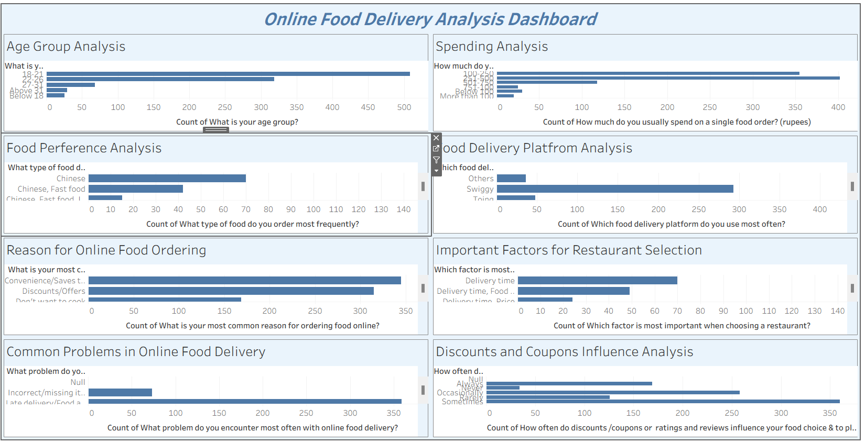
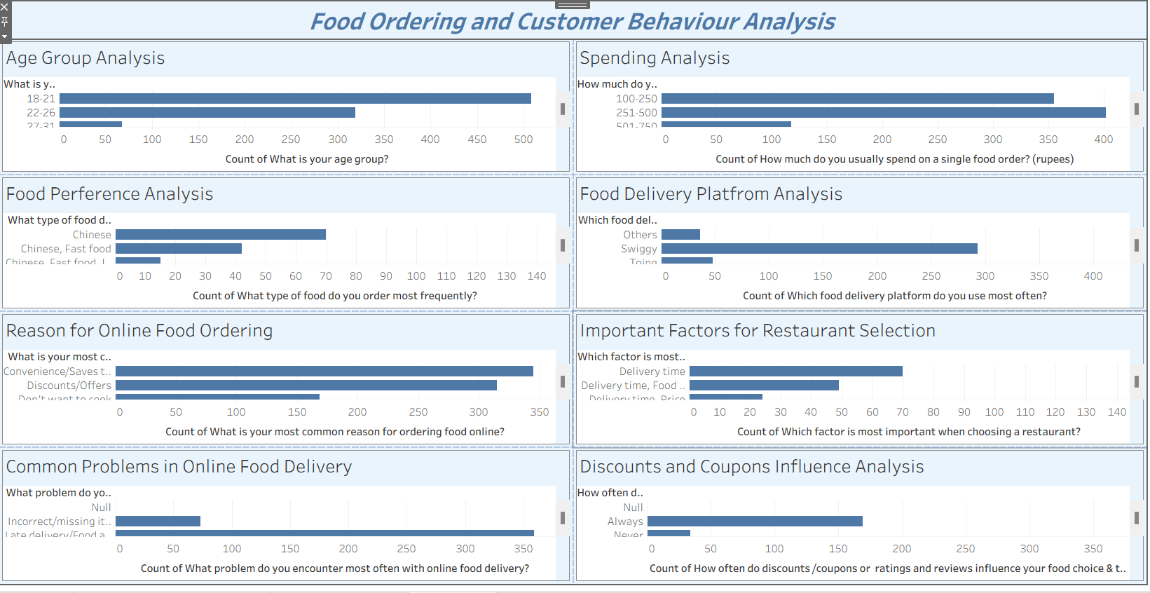
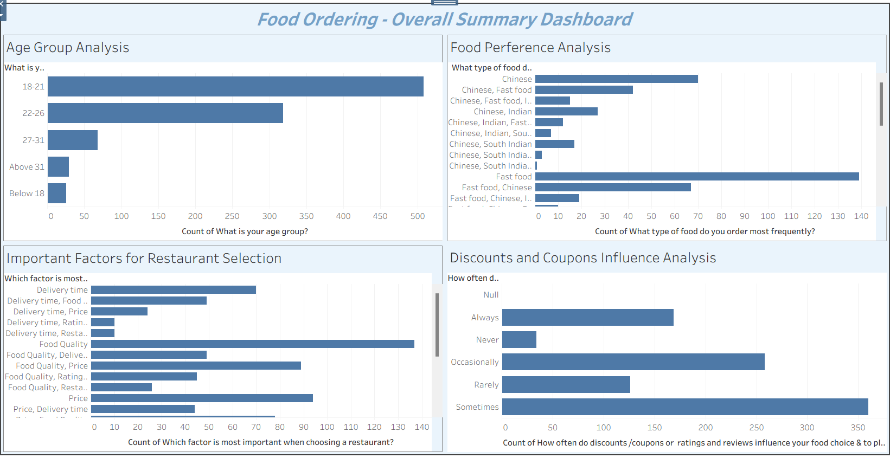
- Customer Age Group Analysis
The dashboard helps understand the age groups of customers who use online food delivery services.
- Customer Spending Patterns
The spending analysis shows how much customers usually spend on a single food order.
- Food Preferences
The dashboard helps identify the types of food customers order most frequently.
- Food Delivery Platform Usage
The analysis helps compare the food delivery platforms used by customers.
- Customer Ordering Behaviour
The dashboard provides insights into reasons for ordering food online, restaurant selection factors, common delivery problems, and the influence of discounts and coupons.
Overall Outcome: The three Tableau dashboards present online food delivery survey data in a clear and understandable way. They help analyze customer preferences, spending habits, ordering behaviour, and food delivery trends.

